TELFORD & WREKIN COUNCIL

CABINET – 4 November 2021

TELFORD & WREKIN COUNCIL BECOMING CARBON NEUTRAL UPDATE

REPORT OF DIRECTOR: COMMUNITIES, CUSTOMER AND COMMERCIAL SERVICES

LEAD CABINET MEMBER – COUNCILLOR CAROLYN HEALY, CABINET MEMBER FOR VISITOR ECONOMY, HISTORIC & NATURAL ENVIRONMENT AND CLIMATE CHANGE

PART A) – SUMMARY REPORT

- SUMMARY OF MAIN PROPOSALS

The next United Nations Climate Change Conference (COP26) is being held in Glasgow this November – with countries from around the world coming together to discuss the global climate emergency. Through the Marches Local Enterprise Partnership, the Council has secured £5k funding to showcase the innovative work being undertaken in the Borough as a part of the COP26 fortnight. The Council has also worked with the Local Government Association on its Pass the Planet campaign to showcase to other local authorities its ground breaking work in being only the second Council in the UK to develop and operate a solar farm.

As COP26 gets underway, this report provides a timely update on what the Council is doing to tackle climate change, both directly and in partnership with others.

The Council has continued to implement its own action plan through the pandemic. The last published update in March 2021 showed that the Council had reduced emissions by 36% in 2019/20 compared to the previous year, building on sustained reductions over the previous 10 years. This report provides a further update on progress in delivering the action plan since March 2021. It is evident that the pandemic has quickened the move towards new ways of working and lessened travel which has enabled a further drop in emissions. Compared to 2019/20, the Council's carbon emissions in 2020/21 reduced by approximately 1,687 tonnes CO_{2e} (33%) from 5,055 tonnes CO_{2e} to 3,368 tonnes CO_{2e}.

The Council has continued to prioritise this work, recognising the need to respond to the climate emergency as well as the pandemic. Section 4.2 of the report sets out the progress that has been made.

The Council realises that in order to deliver the action plan, funding is required to implement the actions. The Council is one of only a very few Councils from across the Country proposing to fund actions through a £1 million Community Municipal Fund Bond (CMB), as set out in Section 4.2.4 of this report. This funding will help to deliver key climate change projects that will benefit the community such as EV charging points, a community forest, as well as a public e-bike hire scheme for the Borough. The CMB will also enable local residents and organisations to invest in and make a positive contribution to the Borough becoming carbon neutral.

The Council has also continued to play an active role as a member of the Telford & Wrekin Borough Climate Change Partnership in developing a draft action plan to help move the Borough towards carbon neutrality. The Partnership has now completed consultation on the draft plan with 525 people, including children and young people, taking part.

The Council has also run a range of communication campaigns in the last six months to help residents, businesses and communities make changes to reduce their carbon footprints and run plastic free lifestyles. These have included a plastic free litter pick in 8 areas of the Borough, the Ocean Fish Trail art project involving 23 local schools and a new Carbon Watchers pilot that will involve 10 of the Council’s Climate Change Champions including the Cabinet Member for Visitor Economy, Historic & Natural Environment and Climate Change, working as a group to reduce their carbon footprint over a 6 month period.

- RECOMMENDATIONS

That Cabinet:

- Notes the progress the Council has made over the last 12 months in its journey to become carbon neutral by 2030 and how the Council will continue to work to reduce carbon emissions from the Council’s operations and activities and influence carbon reduction Borough-wide;
- Approves the launch of a £1 million Community Bond as detailed in this report and delegates authority to the Director: Finance and Human Resources to agree terms and any documentation to give effect to the implementation of the bond and any projects as detailed in this report.
- Notes that this report is in relation to the Council’s response to the Climate Emergency Declaration and will be referred to Full Council for information as part of the ‘Matters Determined by the Cabinet’ report.
- SUMMARY IMPACT ASSESSMENT

COMMUNITY IMPACT | Do these proposals contribute to specific Co-Operative Council priority objective(s)?
 | Yes | This initiative will contribute to all the Council’s priorities but particularly :  • Our natural environment is protected – we are taking a leading role in addressing the climate emergency
 | Will the proposals impact on specific groups of people?
 | No
TARGET COMPLETION/DELIVERY DATE | The Council has made a commitment to achieve carbon neutrality in relation to its services and operations by 2030.
FINANCIAL/VALUE FOR MONEY IMPACT | Yes | A capital allocation of £4m to support Climate Change initiatives is included in the capital programme. This will be allocated to schemes as required within the Action Plan and appropriate finance support provided.  The Public Works Loans Board (PWLB) is currently one of the main sources of long-term borrowing for local authorities i.e. borrowing to fund the approved capital programme. Community Municipal Bonds are an alternative to PWLB and are an approved source of borrowing already included in the 2021/22 Treasury Strategy which was agreed by Full Council in March 2021. Dependent on how much money is raised via the bond, funding could be supplemented by PWLB.  The gross cost to the Council will be comparable with prevailing PWLB rates for similar durations, including the fee payable to Abundance. It should however, be noted that the Council is currently taking advantage of short-term borrowing, mainly from other Local Authorities, which is currently available at interest rates which are considerably lower than PWLB. However, when borrowing, a balance between securing low interest rates and achieving certainty of interest costs has to be achieved and diversification of borrowing sources can help to achieve this. However, the main reason for issuing this bond will be specifically to support climate change.  The administration of the bond will be managed by Abundance, including making interest payments to investors and responding to any queries from investors. The Council will make the agreed principal and interest repayments to Abundance. In common with other borrowing sources, there is also an arrangement fee.  Abundance was launched in 2012 and is regulated by the Financial Conduct Authority and has a continuity plan that includes appropriate arrangements and safeguards if they were to become insolvent.  The Council retains responsibility to manage and deliver the individual projects.  PH 22/9/21
LEGAL ISSUES | Yes | The Climate Change Act 2008 (as amended) establishes a legally binding target to reduce the UK’s greenhouse gas emissions by 100% by 2050 when compared with the 1990 baseline. At a local level, Section 19(1A) of the Planning and Compulsory Purchase Act 2004 requires local planning authorities to include in their local plans, policies designed to secure that the development and use of land in the local planning authority's area contribute to the mitigation of, and adaptation to, climate change. In the management of its activities, provision of its services and performance of its functions, local councils are in a position to play a vital role in meeting the challenges posed by climate change. The Council has wide scope to decide how best to address these challenges.  The Council has the power to raise finance through Community Municipal Bonds and due diligence will be carried out prior to the formal launch of the Community Municipal Bond.  Implementation of the proposals in this report may give rise to specific legal issues which will be picked up going forward.  (IR/EH 29.9.21)
ENVIRONMENTAL IMPACT | Yes | The Climate Emergency declaration was resolved with all party support at Full Council in July 2019 due to extreme concern about the impact of climate change and the urgent need for action. This report provides an update on the Council’s Action Plan. Therefore, the actions set out in this report are designed to have a positive effect on the environment and climate. The content and recommendations contained within this report are expected to reduce emissions of CO₂ within the Council and across the Borough.
OTHER IMPACTS, RISKS & OPPORTUNITIES | Yes | Risks: The Climate Change Committee Independent Assessment of UK Climate Risk for the UK’s third Climate Change Risk Assessment (CCRA3), published in June 2021 sets out the priority climate change risks for the UK.  In summary, risks in the report were:  • The impacts of climate change on the natural environment.  • An increase in the range, quantities and consequences of pests, pathogens and invasive species.  • The risk of climate change impacts, especially more frequent flooding and coastal erosion, causing damage to infrastructure services.  • A reduction in public water supplies due to increasing periods of water scarcity.  • The impact of extreme temperatures, high winds and lightning on the transport network.  • The impact of increasing high temperatures on people’s health and wellbeing.  • Increased severity and frequency of flooding.  • Disruption to the delivery of health and social care services due to a greater frequency of extreme weather.  • Damage to cultural heritage assets as a result of temperature, precipitation, groundwater and landscape changes.  • Impacts internationally that may affect the UK, such as risks to food availability, safety and security, risks to international law and governance from climate change that will affect the UK, international trade routes, public health.  Therefore there are significant risks as outlined should the Council fail to mitigate climate change and ensure that residents, businesses and the natural environment are able to adapt to the future climate.
IMPACT ON SPECIFIC WARDS | No | Borough-wide impact

PART B) – ADDITIONAL INFORMATION

- INFORMATION

4.1 BACKGROUND

4.1.1 Global Context

The Sixth Intergovernmental Panel on Climate Change (IPCC) report published in August 2021 provided the starkest warning to date on climate change with some changes to the climate deemed to be irreversible.

It states that within the next twenty years, temperatures will likely rise by 1.5 degrees above pre-industrial levels. Drastic reductions in greenhouse gas emissions are required to prevent this unprecedented change.

World Leaders from 197 countries will meet for the 26th 2021 United Nations Climate Change Conference (COP26) this November in Glasgow. Countries will be asked to bring forward ambitious greenhouse gas emissions targets.

The UK’s goals for COP26 are:

- Secure global net zero by 2050 and keep 1.5 degrees within reach.
- Adapt to protect communities and natural habitats.
- Mobilise finance.
- Work together to deliver.

4.1.2 National Context

In 2019 the Government amended the Climate Change Act and committed the UK to achieving net zero by 2050.

On 20th April 2021 the Government announced that it would reduce emissions by 78% by 2035 compared to 1990 levels as part of its carbon budget.

4.1.3 Local Action

Since declaring a Climate Emergency in July 2019, the Council has produced annual updates to the Council’s Climate Change Action Plan – this will be the third update.

The baseline report in February 2020 noted emissions had fallen by 44% from 14,173 tonnes CO_{2e} to 7,958 tonnes CO_{2e,} from 2005 to 2018.

The March 2021 update report noted that the Council had continued to make progress, the Council's carbon emissions in 2019/20 reduced by approximately 2,903 tonnes CO_{2e} (36%) from 7,958 tonnes CO_{2e} to 5,055 tonnes CO_{2e}.
4.2 CARBON NEUTRAL COUNCIL

4.2.1 Carbon Emissions 2019/20

The Council has continued to monitor emissions from the following activities:

- Corporate estate;
- Street lighting;
- Transport and travel.

Compared to 2019/20, the Council's carbon emissions in 2020/21 reduced by approximately 1,687 tonnes CO_{2e} (33%) from 5,055 tonnes CO_{2e} to 3,368 tonnes CO_{2e}.

Reductions in emissions have been through undertaking actions from the Council’s Climate Change Action Plan as well as through new ways of working which the Council has brought forward, in part due to the pandemic.

Electricity from the corporate estate and street lighting has continued to reduce due to the enhanced green energy tariff as well as the Council’s continued commitment towards retrofitting its estate. For example:

- Street lighting conversion from traditional street lights to LED lighting is now at 99.31% with only 130 lights left to be converted;
- All council owned car park lights and high masts have now been converted to LED lighting;
- 87% of newly adopted street lights have been converted to LED lighting, with only 32 to be converted once they have been adopted.

In regards to transport and travel, due to news ways of working, staff travel has reduced by more than half. To continue to keep staff travel as low as possible, while not affecting service delivery, the Council has commissioned a staff travel plan which is due to be completed to outline measures to sustain this reduction in travel. The Council has also:

- organised a promotion campaign in September 2021 on the Zenith Salary Sacrifice Car Lease Scheme to highlight offers to staff on electric vehicles and to provide information on EVs;
- started the procurement process to procure 6 EV vans for the Enforcement Team, saving approximately 12,908t CO_{2e} adding to the 6 EV vans brought for the team last year;
- started the procurement process to procure 2 e-bikes for enforcement officers.

The pie chart below shows that the Council's remaining residual carbon footprint was from gas use from the corporate estate:

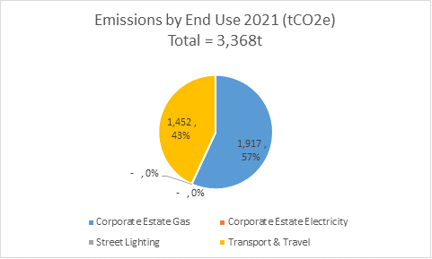

A lot of Council buildings are controlled by building management systems to control energy demand and usage. The Council has high efficiency boilers installed. Additionally, the Council successfully applied for funding from the Public Sector Decarbonisation Fund to install air source heat pumps and improved insulation at Newport Leisure Centre. The Newport tender process will close early November 2021. The Council are also actively exploring with West Mercia Energy the purchase of bio-methane certificates to offset natural gas consumption in the short term, while reducing gas consumption in total.

The case studies below provide a snapshot of some of the actions completed since the last update report in March 2021. Some of these actions have contributed to reducing the Council’s own emissions and some are more community-focused where the Council has played a leadership role to support the wider Borough becoming carbon neutral.

Overall, good progress has been made again in reducing carbon emission reductions in 2020/2021. However, the pandemic has accelerated the reductions. The council will continue to invest in actions to keep on this trajectory.

4.2.2 Carbon Sequestration (Storage)

There is also a Biodiversity Crisis, the action plan includes a range of projects to enhance, restore and create heathland, species rich grassland, wetland habitats and woodland. Protecting and enhancing habitats also protects a range of species. Further details will be published in a Local Nature Recovery Strategy.

At a minimum the draft Local Nature Recovery Strategy will set out proposals to enhance, restore or create up to: 15ha of heathland 30ha of species rich grassland, and 25ha of wetlands on land in the direct ownership of the Council.

The Environment Bill is to be assented in autumn 2021 and the Local Nature Recovery Strategy is reliant on the progress of the Bill and the associated guidance which will be released following assent. In the meantime, the Council has secured funding from Natural England and has launched a habitat mapping project in September 2021 with volunteers and local specialists. The volunteers have been registered and the training dates have been set.

The 15ha of heathland and 30ha of species rich grassland, in the direct ownership of the Council will start to be delivered in winter 2021.

The Council also secured Green Recovery Challenge funding with the national charity ‘Buglife’ to deliver grassland enhancements at Rough Park Meadow. This work is underway and will be delivered by September 2021.

To make sure developments contribute towards the maintenance and/or extension of the Borough’s Canopy Cover, the Council are drafting a Tree Replacement Standard for development applications which result in tree loss. This is will assist in maintaining the Borough’s 15% tree canopy cover, the standard will be published in November 2021.

The Council launched the Trees4TW initiative in November 2020 as part of National Tree Week, delivered 8,600 trees to local residents and landowners. Due to unprecedented demand, another 5,925 trees and hedgerow species are now being delivered to people who had applied for trees last planting season. These trees will store approximately 1452500kg of carbon per year.

To encourage further tree planting, the Council launched the Seeds4TW campaign in September 2021 to encourage residents, schools, organisations to grow trees from seed which can be found in public spaces for free all over the Borough. The dominate species within the borough range from: Maple, Oak, Ash, Beech, Birch, Hawthorn, Cherry, Poplar, Willow, Lime, Alder; to Pine.

The Council is also supporting the Queen’s Green Canopy project www.queensgreencanopy.org, which is a national campaign encouraging people to plant a tree to commemorate Her Majesty’s service over the last 70 years. It will also create a lasting environmental legacy for future generations. The Council is donating mature trees to be planted in a public space in every Town and Parish. The Council will also be planting additional trees on its own land and will be encouraging residents, schools and land-owners to ‘plant a tree for the jubilee’.

4.2.3 Future Commitments

The Council’s future pathway to becoming carbon neutral by 2030 is set out in the carbon budget below. A carbon budget is the cumulative amount of carbon dioxide (CO2) emissions permitted over a period of time to keep within a certain temperature threshold.

This is based upon an annual carbon footprint as follows:

Year | 21/22 | 22/23 | 23/24 | 24/25 | 25/26 | 26/27 | 27/28 | 28/29 | 29/30 | 30/31
Carbon Footprint (tCO_{2e}) | 4,136 | 3,676 | 3,217 | 2,757 | 2,298 | 1,838 | 1,379 | 919 | 460 | 0

As depicted, the Council is well underway to meeting it carbon neutral target, however as noted previously, the acceleration of carbon reductions has been due to the pandemic and the resultant news ways of working. The Council is keen to embed these positive changes through its accommodation review and the staff travel plan. Some of these changes which have now been embedded include, blended ways of working for office based staff and the use of Teams to avoid unnecessary journeys.

4.2.4 Community Municipal Investments

The Council is seeking the opportunity to use community municipal bonds to fund some of the projects in the action plan. The community bond will be focussed on capital schemes.

The Council has a commitment to become carbon neutral by 2030, whilst at the same time has to identify funding to achieve this priority. There is an opportunity for the Council to help address these challenges through the issuing of
‘Climate emergency bonds’ that utilise individuals’ spending power to deliver schemes comparable to the Public Works Loans Board (PWLB) rate.

The Council would have the ability to raise finance, as an alternative to PWLB
but this finance would come via residents and investors investing in a community bond specific to Telford & Wrekin Council.

The scheme works, and is structured, as a bond. The scheme would be an accessible way for people to invest in green projects locally with £5 being the minimum investment. Investments are for a fixed period and investors will receive income at regular intervals.

The bond would be issued with the help of a company, Abundance, who are FCA (Financial Conduct Authority) registered and would administer the bond
(https://www.abundanceinvestment.com/).

The scheme would work by the Council selecting specific actions from the action plan. The selected actions would need to be capital in nature as the bond would need to fund capital works just as PWLB borrowing does at present. The selected actions would need to be at a minimum of £1m. It is proposed that the Council will select climate change initiatives such as a community forest, a multi partner electric vehicle framework across car parks in Telford and Wrekin and a public e-bike hire scheme for the Borough. This would clearly meet the Council’s strategic priority for ‘Our natural environment is protected – we are taking a leading role in addressing the climate emergency’. This platform would then provide the Council with the ability to communicate effectively with residents and investors on the schemes selected.

The gross cost to the Council for the bond will be comparable with the prevailing PWLB rates for similar durations, including the fee payable to Abundance.

It should also be attractive as local authorities are seen as a relatively low risk for investors, whilst still offering an attractive return to the investor. There is a further benefit as the investment would have a very strong social and ethical basis for the investor, which is becoming increasingly important to the financial market and individuals.

The issuing of the bond and regular interest payments, gives the Council a good opportunity to communicate and engage with investors, so that the Council can promote what the investment has delivered for the Council’s Climate Change Action Plan. The Council will also be able to promote future schemes that it is completing as part of the action plan and engage with residents and investors on these.

The investor also has the ability to donate their financial return of interest back to other community climate change projects rather than take this as a financial return to support additional hard to fund measures and research indicates that there is appetite for this.
West Berkshire Council Case Study

2020 saw West Berkshire Council successfully issue the UK’s first ever local government green bond.

The West Berkshire bond raised £1 million in less than three months, financing rooftop solar panels on Council buildings, expansion of cycleways, flood defence work and installation of LED lighting on traffic lights.

The CMI offered returns of 1.2% per year, over a 5 year term, using an annuity
structure to repay capital in instalments over the life of the bond. The minimum investment level was £5. The £1 million target was reached ahead of schedule, closing on 10th October 2020. It attracted 640 investors, with a quarter investing £100 or less.

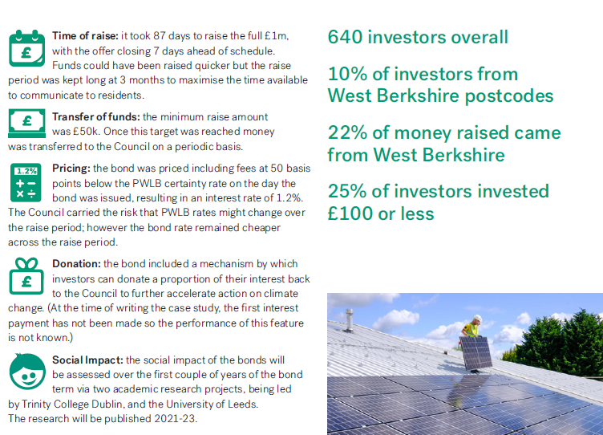

A CMB is a bond or loan instrument issued by a Local Authority directly to the public via an internet based crowdfunding platform. Due to the low-cost nature of crowdfunding, CMBs can be issued via an online process at rates which are comparable with Public Works Loan Board borrowing rates and terms, while also providing a competitive investment product for local savers and investors. The bonds are targeted at people living within the area of the issuing authority but are also available to people living across the UK. CMBs are built to prioritise individual investment but are compatible with the requirements of institutional investors such as pension funds.

As a part of this report the Council is asking for approval to officially launch the community bond for the authority to raise funds to deliver climate change actions.

4.3 CARBON NEUTRAL BOROUGH

The Council has played a key role in supporting others in the Borough to tackle climate change and improve the Borough’s environment:

4.3.1 Telford and Wrekin Climate Change Partnership Action Plan

To address the Climate Emergency, the Council set up the Telford and Wrekin Climate Change Partnership. Through the Partnership, the Council is working collaboratively with businesses, educational establishments, community groups, Town & Parish Councils and other public sector organisations, using our partners’ knowledge and expertise to develop the Borough Action Plan for the Borough to become carbon neutral by 2030.

The Borough Action Plan was drafted by the Partnership and consulted upon with the residents of the Borough from 21 June 2021 – Friday 30 July 2021.

The Climate Change consultation was carried out in two parts:

Online borough wide survey – The survey focussed on the 6 thematic areas within the draft plan. For each thematic area respondents were asked to prioritise the actions the Partnership has identified based on how strongly they thought these actions would contribute to reducing the Borough’s carbon emissions.

Overall, respondents were satisfied with the Partnership’s approach to tackling climate change (respondents were asked to rank this question on a scale of 0 – 10 with the average rating being 6.59).

A summary of the top priority by theme are set out below:

- Transport
Promote sustainable transport campaigns across the borough
- Energy
Explore the possibility of running a large scale solar panel project on the roof of a local industrial estate.
- Learning, Communications and Public Engagement
Actively promote different green volunteer projects/opportunities as they arise.
- Agriculture, Forestry and other Land Use summary
Identify suitable land for tree-planting and re-establishing hedgerows/extending existing hedgerows.
- Buildings
Encourage all developers to build in an eco-friendly way.
- Industry
Support, expand and promote the borough’s existing repair cafes – where tools and materials are available to fix broken goods, rather than throwing them away.

Children and young people’s consultation – classroom based activity

Primary school children in Telford and Wrekin participated in a series of classroom-based climate change workshops. The consultation involved 387 children, ages 6 to 11, from 14 different classes.

The in-person workshops provided the opportunity for discussion and gave the children a forum to share their ideas, to ask questions, and to expand their understanding of climate change issues.

As with the online survey, these workshops focussed on the 6 thematic areas of the action plan but the themes/actions were adapted through discussion with the children to make it easier for the them to understand and relate to, including colourful slides to accompany the words. A summary of the main results are set out below:

Ranking the themes in order of priority:

- Trees and biodiversity
Plant different species of trees. Look after them so the trees can store carbon and clean the air
- Renewable energy
Solar Panels on schools and other buildings
- Growing food and farming
Promote growing vegetables and fruit
- Learning and sharing
Have eco warriors/champions help others learn to take planet friendly actions.
- Sustainable transport
Convert buses to use clean energy – for example electric or hydrogen.
- Places where we work
Share information on how to recycle properly and promote the waste hierarchy

This information will now be used by the Partnership to finalise the plan and to prioritise delivery of the actions in the Borough Climate Change Action Plan for the short, medium and long term. The full results of the consultation are available at www.sustainabletelfordandwrekin.co.uk

4.3.2 Climate Change Fund

In February 2021, Telford & Wrekin Council launched its Climate Change Fund to help organisations in the Borough to deliver projects aimed at addressing climate change or environmental sustainability. Funding of £100,000 was originally allocated to provide grants to a wide range of organisations, including small businesses and applications were invited for projects which fell within one of the four categories:

• Improve energy efficiency in existing buildings
• Provide renewable/low carbon energy generation
• Sustainable travel
• Reduce waste

Grants could be applied for up to £5000 for community organisations and up to £2500 for businesses, with all applicants required to provide match funding.

The scheme proved extremely popular with 69 applications received. Due to the quality of bids received, £11,000 additional funding was issued and 30 grants have now been awarded, with a number of projects already underway. A more detailed update on this scheme will be reported to Cabinet in the New Year.

Due to the unprecedented demand to the Council’s Climate Change Fund, the Council has committed further funds and reached out to those organisations whose applications did not quite make the final cut to apply for the further funds which have been made available in a closed round this autumn.

4.3.3 Plastic Free

The Council has made a commitment to remove all single-use plastic from the Council’s operations and activities, replacing them with sustainable alternatives by 2023. Alongside, the Council has established the Plastic Free Taskforce, which is a partnership consisting of educational establishments, local businesses, community organisations and Town Councils all working together to achieve plastic free community status across the borough.

In January 2021, the Taskforce developed a high level action plan based around the key criteria to become a plastic free community. All Town Councils have signed up to achieve the plastic free status. The Council have also introduced a new recycling process into the Street Champion scheme - they now have additional clear bags they can use to separate recycling into (this is in addition to the blue bags for general waste).

Working in partnership with Town/Parish Councils, local business and stakeholders, the Council will begin by installing dual-recycling bins across high footfall areas (including but not limited to Oakengates, Newport and Wellington) in the Borough including Telford Town Park and the Borough’s Parks. By the end of October 2021 a pilot will be in the Town Park.

A Green Guide is being produced by the Taskforce, which will offer practical advice for local businesses and other organisations on how to improve sustainability, including reducing single-use plastics and their carbon footprint. It will also enable visitors of the site to find local businesses that are already engaged on this agenda so they know where they can go to support them, where to go to refill etc.

4.3.4 Community Engagement

Since the Climate Emergency Declaration, the Council has been committed to raising awareness amongst residents, local communities and businesses of the impact of climate change and the positive steps that people can take to reduce this.

The Council has run a programme of communication campaigns over the last 6 months, which included:

- The Great British Spring Clean 28 May – 13 June 2021
Great British Spring Clean 2021 - Plastic Free Litter Picking in Telford and Wrekin - YouTube
On 11 and 12 June 2021, Telford & Wrekin Council and local communities came together to support Keep Britain Tidy’s annual Great British Spring Clean. Councillors, council staff, Street Champions, Climate Change Champions, Community Action Teams, community groups, individuals and businesses all got involved across Telford and Wrekin to pick litter from our streets.
Communities that took part with local Plastic Free litter picks this year were:
• Rough Park, Woodside
• Ironbridge
• Dawley Pools
• Dawley Park and Malinslee
• Wellington area
• Oakengates/The Cockshutt
• Admaston Green
• Hollinswood Primary School

From the organised events we had 85 bags of general waste and 56 bags of recycling with approximately 250-300 people taking part.

- Ocean Fish Trail (August 2021)
An Ocean Trail art installation made up of 24 giant fish debuted at the Telford Balloon Fiesta before going on display in the Town Park’s Chelsea Gardens. The art project is a partnership between Telford & Wrekin Council and the British Ironwork Centre to help educate schoolchildren and raise awareness of the need to protect our oceans and marine life from deadly plastics pollution. This project has engaged young people to learn about the impact plastic is having on our oceans. The fish were decorated by pupils from 23 schools in Telford and Wrekin, and the shoal was joined by the prototype created and decorated by the Ironworks Centre. Each school has painted and decorated their fish to their own design, creating a colourful trail that will catch the eye of passers-by and help raise awareness of the plight of our oceans and marine life.
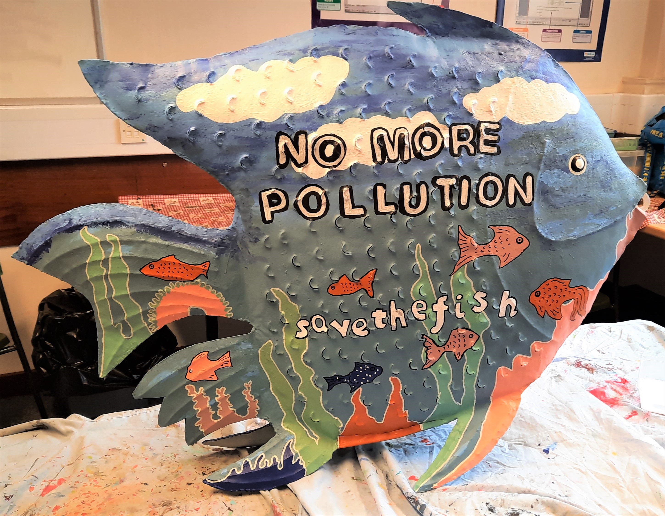

- Pass the Planet (September 2021) - In the run up to COP26, the Local Government Association (LGA) are showcasing best practice from councils across England and Wales through their Pass the Planet campaign https://www.local.gov.uk/pass-the-planet. With the UN Climate Change Conference (COP26) being hosted in Glasgow this November, the LGA are using the opportunity to share and showcase the work councils are doing to address climate change. Through Pass the Planet, the LGA are promoting good practice to support universal learning and share innovative solutions which other councils can scale up or replicate. Our solar farm is showcased as an example of best practice, https://www.local.gov.uk/case-studies/telford-wrekin-council-publicly-owned-solar-farm

A calendar of communication will continue during 2022. As well as linking in to national and international campaigns, the Council has also been successful in obtaining £5k via the Marches LEP from BEIS (Department of Business Energy and Industrial Strategy) to host events as part of a regional green zone in the Marches to promote COP26 from 31st October to 12th November 2021. One of the events will showcase local narratives around carbon reduction projects that have been delivered through low carbon funds, such as the Marches Renewable Energy grant and through the Councils own Climate Change Fund. This will demonstrate what businesses and organisations are doing in the Borough to support Net Zero ambitions.

The second event will take the Ocean fish trail on tour – we will take 4 or 5 of the fish to schools in the borough that were not a part of the 23 participating schools. Assemblies will be delivered at the schools to children with the fish on site. The assemblies will educate the children on the topic of single use plastic pollution. One assembly will be recorded to showcase the assembly to all other schools that are interested in and out of the Borough.

To further extend the reach of this successful project, we propose to take the fish to the Arthog centre, Fairbourne beach (North Wales), on Friday 5th November 2021. Approximately 50 Children from the borough’s primary schools will be present. The fish will be taken onto the beach and a short talk delivered to the children on plastic pollution. A template of a large fish will be drawn in the sand. A litter pick will be undertaken with the children at the beach and the children will fill the fish template with the plastic litter found.

The Council’s volunteering opportunity - Climate Change Champions, now have 22 signed up from across the Borough. The Carbon Watchers project will be piloted by some of the volunteers including the Cabinet Member for Visitor Economy, Historic & Natural Environment and Climate Change to assess, evaluate and reduce their own carbon footprint. This initiative will be launched during COP26.

This is a pilot 6 month programme where the volunteers will be able to enter general information about their carbon usage in their lifestyle (e.g average meter readings, meat vs non-meat diet, shopping habits etc) into an online carbon calculator once a month. The volunteers will be asked to meet as a group with the project coordinator, on a monthly basis, to discuss progress and ways of reducing their emissions.
The Council will evaluate the pilot at the end, to see if it can be rolled out borough-wide.

- PREVIOUS MINUTES

None.

- BACKGROUND PAPERS

IPCC, 2021: Climate Change 2021: The Physical Science Basis. Contribution of Working Group I to the Sixth Assessment Report of the Intergovernmental Panel on Climate Change [Masson-Delmotte, V., P. Zhai, A. Pirani, S.L. Connors, C. Péan, S. Berger, N. Caud, Y. Chen, L. Goldfarb, M.I. Gomis, M. Huang, K. Leitzell, E. Lonnoy, J.B.R. Matthews, T.K. Maycock, T. Waterfield, O. Yelekçi, R. Yu, and B. Zhou (eds.)]. Cambridge University Press. In Press.

Report prepared by Harjot Rayet, Climate Change & Sustainability Coordinator, Telephone: 01952 384219, Email: harjot.rayet@telford.gov.uk

https://www.ukclimaterisk.org/wp-content/uploads/2021/06/CCRA-Evidence-Report-England-Summary-Final.pdf
https://www.ipcc.ch/report/sixth-assessment-report-working-group-i/
The UK’s carbon budgets place a restriction on the total amount of greenhouse gases the UK can emit over a five year period.
All new street lighting within the borough must be in accordance with the specification outlined within the Telford & Wrekin Council Street Lighting Design Guide, August 2017. This stipulates LED luminaires. All new developments requiring street lighting will not gain the necessary approvals and subsequent highway adoption without providing LED lighting in accordance with this document. The only exception being with the adoption of older sites which were constructed prior to this design guidance.
CO₂ storage for 14525 trees based on a tree absorbing CO₂ at a rate of 10kg per year, https://granthaminstitute.com/2015/09/02/how-much-co2-can-trees-take-up/ and https://www.greenenergyconsulting.co.uk/treeplanting.php
Abundance is an FCA regulated investment platform founded in 2012.
To gain as much traction as possible for the consultation, the Council hosted a ‘virtual’ live Q&A session on Facebook with panel members from the Partnership and chaired by Cllr Carolyn Healy. 1,954 minutes of the content was viewed. It generated 65 live viewers, 75 live comments and 23 comments. The consultation overall had: o 164.8k reach o 39.5k impressions o 188 link clicks o 23 comments o 34 likes o 51 shares o Generated 1,627 hits on the consultation page The campaign led to: • 150 comments on the consultation with 138 completions
Transport; Energy; Learning, Communications and Public Engagement; Agriculture, Forestry and Other Land Use; Buildings; Industry
Schools taking part in the project were: Apley Wood Primary School; Coalbrookdale & Ironbridge CE Primary School; Grange Park Primary School; Hadley Learning Community Primary; Halesfield Day Nursery Centre; Hollinswood Primary School; Ladygrove Primary School & Nursery; Lawley Primary School; Lilleshall Primary School; John Fletcher of Madeley Primary School; Millbrook Primary School & Nursery; Newport Girls’ High School; Newport Infant School; Old Park Primary School & Nursery; Randlay Primary School & Nursery; St Lawrence C of E Primary School; St Matthew’s CE (Aided) Primary School and Nursery Centre; St Peter's CE Primary & Nursery School; Telford Priory School; Tibberton CE Primary School; Woodlands Primary and Nursery School; Wrockwardine Wood Infant School & Nursery; Wrockwardine Wood Junior School

